## FITNESS AND YOGA- Project

Authored by Y.Kawin 12 C

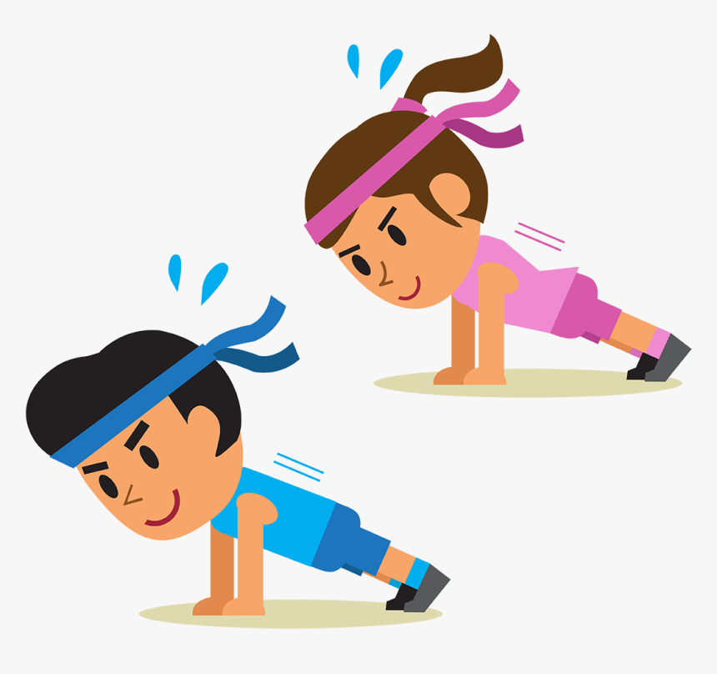

FITNESS AND YOGA

PHYSICAL EDUCATION

12 C

KAWIN YOGAM

JSSPS1967

ACKNOWLEDGEMENT

I am grateful to the CBSE and my school, JSS Private School, Dubai, for allowing me to do this project.

I am greatly indebted to my guide, to my physical education teacher Mr. Subodh Dhyani for imparting valuable knowledge that aided me in the successful culmination of my project. I am highly indebted to my teacher, Mr. Subodh Dhyani for his guidance, constant supervision, and for providing necessary information regarding the project.

I cannot end without thanking my parents and friends, for their constant encouragement, understanding, endless patience and love I could count on and which gave the strength to overcome obstacles while doing this research work. Without their sacrificial help, I could not have dreamt of completing my project successfully.

INDEX

|  |  |
| --- | --- |
| Serial No. | Topic |

|  |  |
| --- | --- |
| 1 | Harvard step test |
| 2 | Rockport one mile test |
| 3 | Chair stand test |
| 4 | Arm curl test |
| 5 | Chair sit and reach Test |
| 6 | Back scratch test |
| 7 | 8 foot up and go Test |
| 8 | Six minute walk test |

|  |  |
| --- | --- |
| 1 | Vajrrasana |
| 2 | Pada Hastasana |
| 3 | Bhujangasana |
| 4 | Ardhmatseyendrasana |
| 5 | Sukhasana |
| 6 | Parvatasana |
| 7 | Tadasana |
| 8 | Ardha Chakrasana |
| 9 | Vakrasana |
| 10 | Shalabhasana |

TEST AND MEASURMENT IN SPORTS

FITNESS

Good health and fitness is not something which one can achieve entirely on our own. It depends on their physical environment and the quality of food intake. Routine exercise helps improve our muscle power. Exercise helps in good oxygen supply and blood flow throughout the body. Heart and lungs work efficiently. Our bones get strong and joints have the pain free movement. We should daily spend at least twenty minutes in our exercise. Daily morning walk improves our fitness level. We should avoid strenuous Gym activities. Exercise burns our fat and controls the cholesterol level in the body. Various outdoor games like cricket, football, volleyball, etc keeps our body fit. Regular exercise maintains our body shape.

The Harvard step test

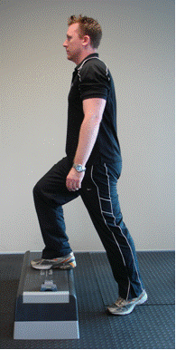

The Harvard Step Test

The Harvard Step Test is used to measure a clients aerobic fitness. Specifically it is a 'predictive test of their VO2max. This page shows you how to conduct the test. The purpose of this test is to predict a clients aerobic fitness using a simple test with minimal equipment.

Equipment required: step or platform 50.8 cm high, stopwatch, metronome or cadence tape.

Procedure: The client steps up onto, and back down from the step at a rate of 30 completed steps per minute (one second up, one second down) for 5 minutes or until exhaustion. Exhaustion is defined as when the client cannot maintain the stepping rate for 15 continuous seconds. The client immediately sits down on completion of the test, and the total number of their heart beats are counted from 1 to 1½ minutes after finishing and from 2 to 2½ minutes after finishing and finally from 3 to 3½ minutes after finishing. The clients heart beats are counted through feeling the clients pulse at their wrist.

Fitness Index = (100 x test duration in seconds) divided by (2 x sum of heart beats in the recovery periods)

Rockport One Mile Test

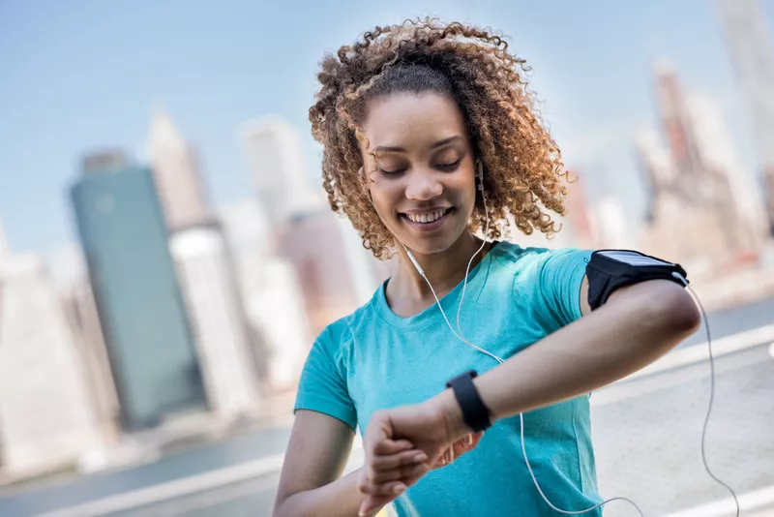

Rockport One Mile Test

The Rockport walking test is an evaluation you can self-administer to determine your cardiovascular fitness.1 The aim of the test is to measure your VO2 max, the maximum amount of oxygen you can utilize during intense exercise, measured in milliliters of oxygen used per kilogram of body weight per minute (ml/kg/min).

Equipment required: 400m track, stopwatch and weighing balance

Procedure: Warm up for 5 to 10 minutes with easy walking.

Start your stopwatch and immediately start walking as fast as you can. Make every effort to push yourself, but avoid jogging.

At the end of the 1 mile, stop your stopwatch and record your time in decimals. For example, 11 minutes plus (30 seconds ÷ 60 seconds) = 11.5 minutes. Take your heart rate immediately.

Calculation: VO2 max = 132.853 - (0.0769 x your weight in pounds) - (0.3877 x your age) + (6.315 if you are male or 0 if you are female) - (3.2649 x your walking time) - (0.1565 x your heart rate at the end of the test)

The Rockport walking test is a valuable tool for anyone wanting to approach exercise safely.

Chair stand test

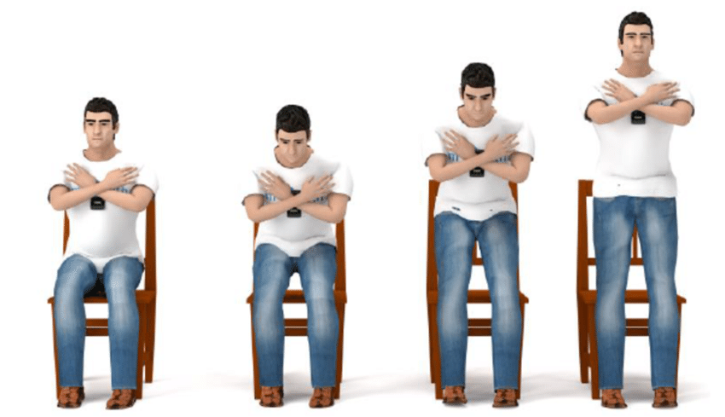

Chair Stand Test

The chair stand test is similar to a squat test to measure leg strength, in which participants stand up repeatedly from a chair for 30 seconds. This test is part of the Senior Fitness Test Protocol, and is designed to test the functional fitness of seniors. This test assesses leg strength and endurance.

procedure: Place the chair against a wall, or otherwise stabilize it for safety. The subject sits in the middle of the seat, with their feet shoulder width apart, flat on the floor. The arms are to be crossed at the wrists and held close to the chest. From the sitting position, the subject stands completely up, then completely back down, and this is repeated for 30 seconds. Count the total number of complete chair stands (up and down equals one stand). If the subject has completed a full stand from the sitting position when the time is elapsed, the final stand is counted in the total.

scoring: the score is the number of completed chair stands in 30 seconds. Below is a table showing the recommended ranges for this test based on age groups (from Jones & Rikli, 2002).

target population: the aged population which may not be able to do traditional fitness tests.

advantages: the equipment is readily available around any home

Arm Curl Test

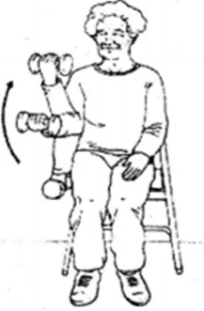

Arm Curl Test

The Arm Curl test is a test of upper body strength, and is part of the Senior Fitness Test (SFT) and the AAHPERD Functional Fitness Test, and is designed to test the functional fitness of seniors. There are slight differences between the protocols for the Senior and AAHPERD tests, such as the weight used for women. This test measures upper body strength and endurance.

equipment required: 4 pound weight (women, AAHPERD), 5 pound weight (women, SFT), 8 pound weight (for men). A chair without armrests, stopwatch.

procedure: The aim of this test is to do as many arm curls as possible in 30 seconds. This test is conducted on the dominant arm side (or stronger side).. Curl the arm up through a full range of motion, gradually turning the palm up (flexion with supination). As the arm is lowered through the full range of motion, gradually return to the starting position. The arm must be fully bent and then fully straightened at the elbow. The protocol for the AAHPERD test describes the

scoring: The score is the total number of controlled arm curls performed in 30 seconds.

target population: the aged population which may not be able to do traditional fitness tests.

Chair Sit-and-Reach Test

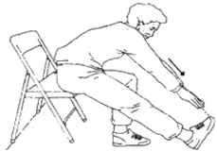

Chair Sit-and-Reach Test

The Chair Sit and Reach test is part of the Senior Fitness Test Protocol, and is designed to test the functional fitness of seniors. It is a variation of the traditional sit and reach flexibility test. This test measures lower body flexibility.

equipment required: ruler, straight back or folding chair, (about 17 inches/44 cm high]

procedure: One foot must remain flat on the floor. The other leg is extended forward with the knee straight, heel on the floor, and ankle bent at 90°. Place one hand on top of the other with tips of the middle fingers even. Instruct the subject to inhale, and then as they exhale, reach forward toward the toes by bending at the hip. Keep the back straight and head up. Avoid bouncing or quick movements, and never stretch to the point of pain. Keep the knee straight, and hold the reach for 2 seconds. The distance is measured between the tip of the fingertips and the toes. If the fingertips touch the toes then the score is zero.

scoring: The score is recorded to the nearest 1/2 inch or 1 cm as the distance reached, either a negative or positive score. Record which leg was used for measurement.

target population: the aged population which may not be able to do traditional fitness tests.

Back Scratch Test

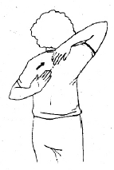

Back Scratch Test

The Back Scratch Test, or simply the Scratch Test, measures how close the hands can be brought together behind the back. This test is part of the Senior Fitness Test Protocol, and is designed to test the functional fitness of seniors. This test measures general shoulder range of motion

equipment required: ruler or a yardstick

Procedure: This test is done in the standing position. Place one hand behind the head and back over the shoulder, and reach as far as possible down the middle of your back, your palm touching your body and the fingers directed downwards. Place the other arm behind your back, palm facing outward and fingers upward and reach up as far as possible attempting to touch or overlap the middle fingers of both hands. An assistant is required to measure the distance between the tips of the middle fingers. If the fingertips touch then the score is zero. Practice two times, and then test two times. Stop the test if the subject experiences pain.

scoring: Record the best score to the nearest centimeter or 1/2 inch. The higher the score the better the result.

target population: the aged population which may not be able to do traditional fitness tests.

Eight foot up and go test

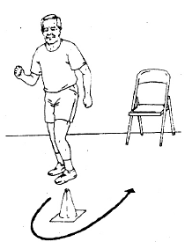

Eight foot up and go Test

The '8 Foot Up-and-Go' is a coordination and agility test for the elderly, which is part of the Senior Fitness Test Protocol. See also the AAHPERD agility test also designed to test agility in the elderly. This test measures speed, agility and balance while moving.

equipment required: stopwatch, straight back or folding chair (about 17 inches/44 cm high), cone marker, measuring tape, area clear of obstacles.

procedure: Place the chair next to a wall (for safety) and the marker 8 feet in front of the chair. Clear the path between the chair and the marker. The subject starts fully seated, hands resting on the knees and feet flat on the ground. On the command, "Go," timing is started and the subject stands and walks (no running) as quickly as possible (and safely) to and around the cone, returning to the chair to sit down. Timing stops as they sit down. Perform two trials.

scoring: Take the best time of the two trails to the nearest 1/10th second.

target population: the aged population which may not be able to do traditional fitness tests.

Six minute Walk Test

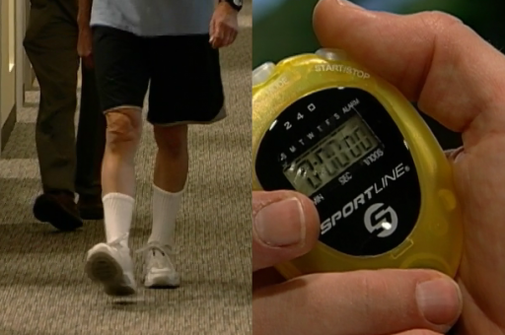

Six minute Walk Test

The 6 Minute Walk Test is a sub-maximal exercise test used to assess aerobic capacity and endurance. The distance covered over a time of 6 minutes is used as the outcome by which to compare changes in performance capacity.

Equipment required: Measuring tape, a stop watch

Procedure: The walking distance of course is marked i.e, 45.72 m or 50 yards in a rectangular area (20 x 5 yards) of 5 yards with cones placed at regular intervals to indicate the distance covered. Efforts are made to walk maximum distance as quickly as possible in 6 minutes. A practice trial is given to the participant. He may stop any time if he desires so.

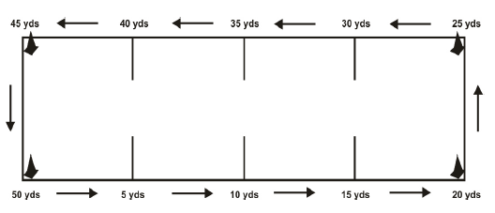

Scoring : measure the distance walked in 6 minutes to the nearest meter.

YOGA AND LIFESTYLE

Yoga is an ancient art that connects the mind and body. It is an exercise that we perform by balancing the elements of our bodies. In addition, it helps us meditate and relax.

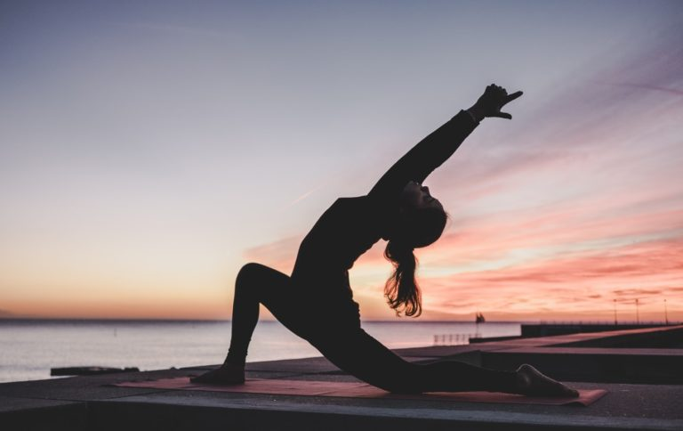Moreover, yoga helps us keep control of our bodies as well as mind. It is a great channel for releasing our stress and anxiety. Yoga gained popularity gradually and is now spread in all regions of the world. It unites people in harmony and peace.

**Lifestyle Disease: Obesity**

Vajrrasana

Procedure: Start by kneeling on the floor. Consider using a yoga mat for comfort.

Pull your knees and ankles together and point your feet in line with your legs. The bottoms of your feet should face upward with your big toes touching. Breathe in and out slowly as you position yourself to sit up straight by straightening your spine. Straighten your head to gaze forward with your chin parallel to the floor. Position your hands palms down on your thighs with your arms relaxed.

Benefits: helping keep the mind calm and stable

curing digestive acidity and gas formation

helping to relieve knee pain

strengthening thigh muscles

Pada Hastasana:

Procedure: Stand with the spine erect, feet together and hands beside the body Slowly bend forward Place the fingers underneath the toes or catch your ankles Maintain your legs and knees active, they should remain straight

Benefits: Massages the digestive organs

Alleviates flatulence, constipation, and indigestion

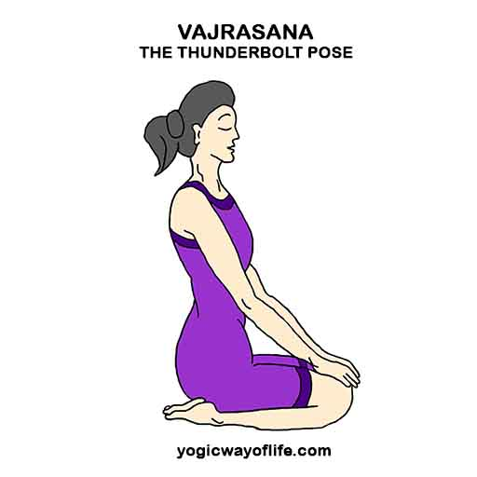

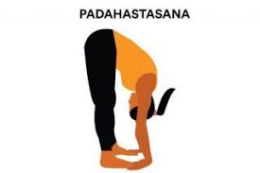

Spinal nerves are stimulated and toned

Increases vitality

**Lifestyle Disease: Diabetes**

Bhujangasana: In order to perform this asana, lie down on the belly on the ground. Keep your hands near the shoulders. Keep your legs close together. Now straighten up your arms slowly, raise the chest. Your head should turn backwards. Keep this position for some time. Then, get back to the normal position. For good results perform this asana 3 to 5 times.

Benefits: Improves flexibility of the upper and middle back

Expands the chest

Improves blood circulation

Reduces fatigue and stress

Ardhmatseyendrasana

Procedure: The left heel is kept under the right thigh and right leg is crossed over the left thigh. After that hold to the right side. In this position move the trunk sideways. Then, perform the same asana in the reverse position.

Benefits: It keeps gall bladder and the prostate gland healthy.

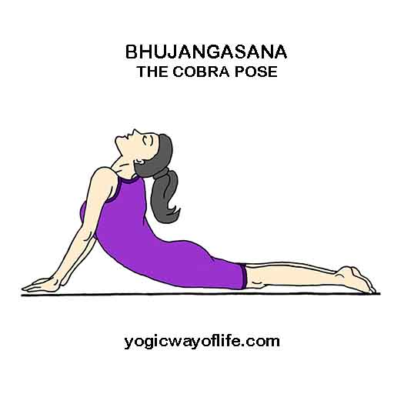

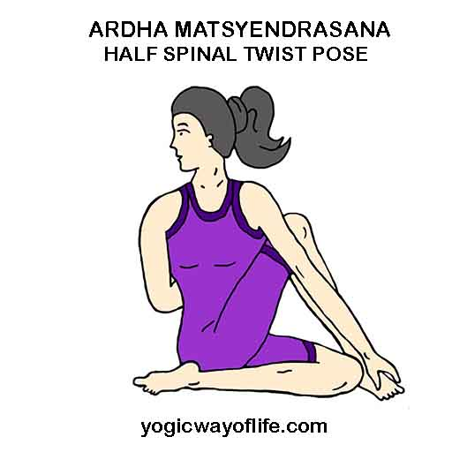

It enhances the stretchability of back muscles

It alleviates digestive aliments

It regulates the secretion of adrenaline and bile and thus is recommended in yogic management of diabetes.

**Lifestyle Disease: Asthma**

Sukhasana

Procedure: Sit down with the legs straight in front of the body. After that bend the left leg and keep the foot under the right thigh. Place the hands on the knees. Chin should be in. Keep the head, neck and back straight, close the eyes. Relax the body

Benefits: It stretches and lengthens spine

It calms your mind

It enhances your peace of mind

It reduces anxiety

Parvatasana

Procedure: Sit in Padmasana or lotus pose. Stretch your arms sideways and bring them over your head slowly. After that let your palms touch each other. Then stretch your hands well without bending your elbows. Keep your spine erect.

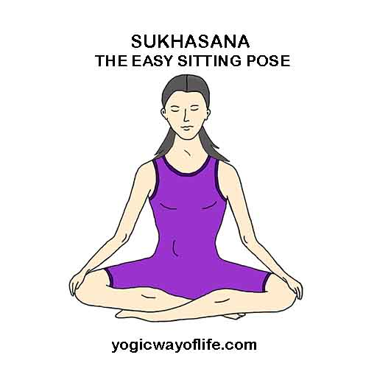

Benefits: It helps in enhancing height

It reduces the extra fat in the back and waist

It is extremely beneficial in case of asthma

**Lifestyle Disease: Hypertension**

Tadasana

Procedure: Stand up in attention pose. Lift your arms upwards. Stretch your hands upwards. Raise your heels and come on your toes. Also pull up your body upwards. After some time breathe out slowly and come to the previous position. Repeat the same exercise 10 or 15 times

Benefits: It reduces obesity

It cures digestive problems

It improves body posture

Ardha Chakrasana

Procedure: Stand straight with both feet together. Hold your hips with your slow hands. Bend backwards without bending your knees with slow inhalation. Remain in this pose for some time. Do it 2 or 3 times

Benefits: It relieves stress and tension

It cures menstrual disorders

It cures mental disorders

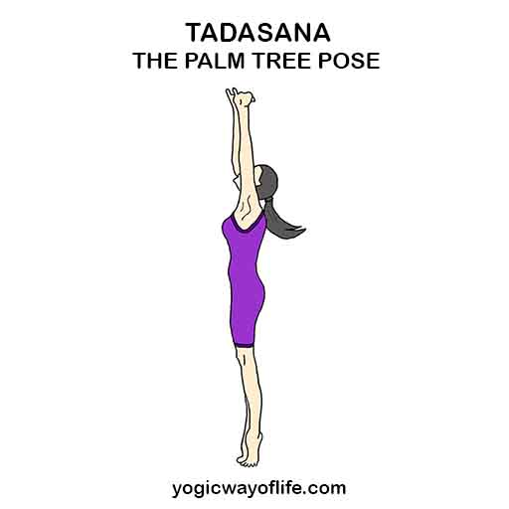

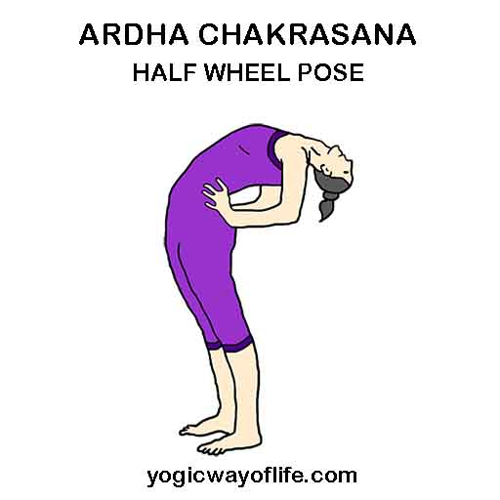

**Lifestyle Disease : Back Pain**

Vakrasana

Procedure: First, sit on a yoga map and stretch your legs stretched out. Try to bend your left leg from the knees and then try to place your foot beside the right knee. Exhale and then twist you’re your waist towards the left and make sure that your spine is straight. Then, try to place your right arm towards the left side foot, and you need to do this in a way that the outer side of the right arm touching the outer side of the left leg. Also, move your right hand beside the left foot. Take your left arm back and try to place your palm on the floor and do this in a way that the trunk is properly twisted and straight. You can practise Vakrasana two to three times.

Benefits: It improves the function of both spinal cord and nervous system

It prevents and controls diabetes

It strengthens kidneys

It reduces belly fat

Shalabhasana

Procedure: In order to perform shalabhasana, lie down in prostrate position. Spread the thigh backwards. Hold your fists and extend arms. Keep your fists under the thigh and then raise your legs slowly as high as you can. For best results

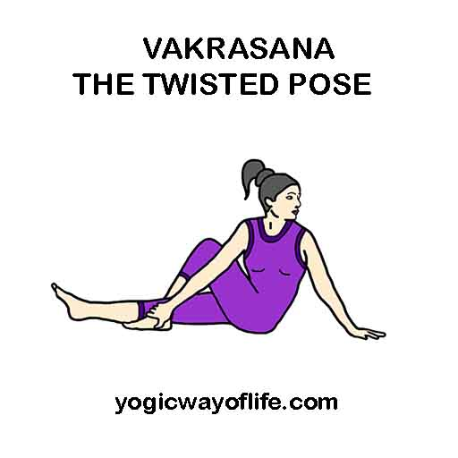

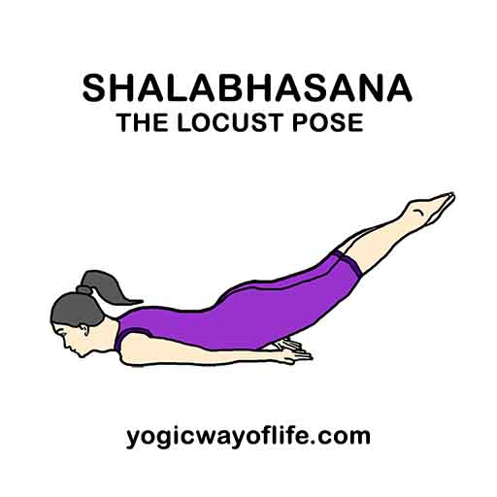hold this position for 2 or 3 minutes and then lower your legs slowly. Repeat the same action for 3 to 5 times.

Benefits: It provides relief to the persons who have mild sciatica and slipped disc problem

It strengthens the muscles of the spine, buttocks and back of the arms and legs

It improves posture

It stimulates abdominal organs